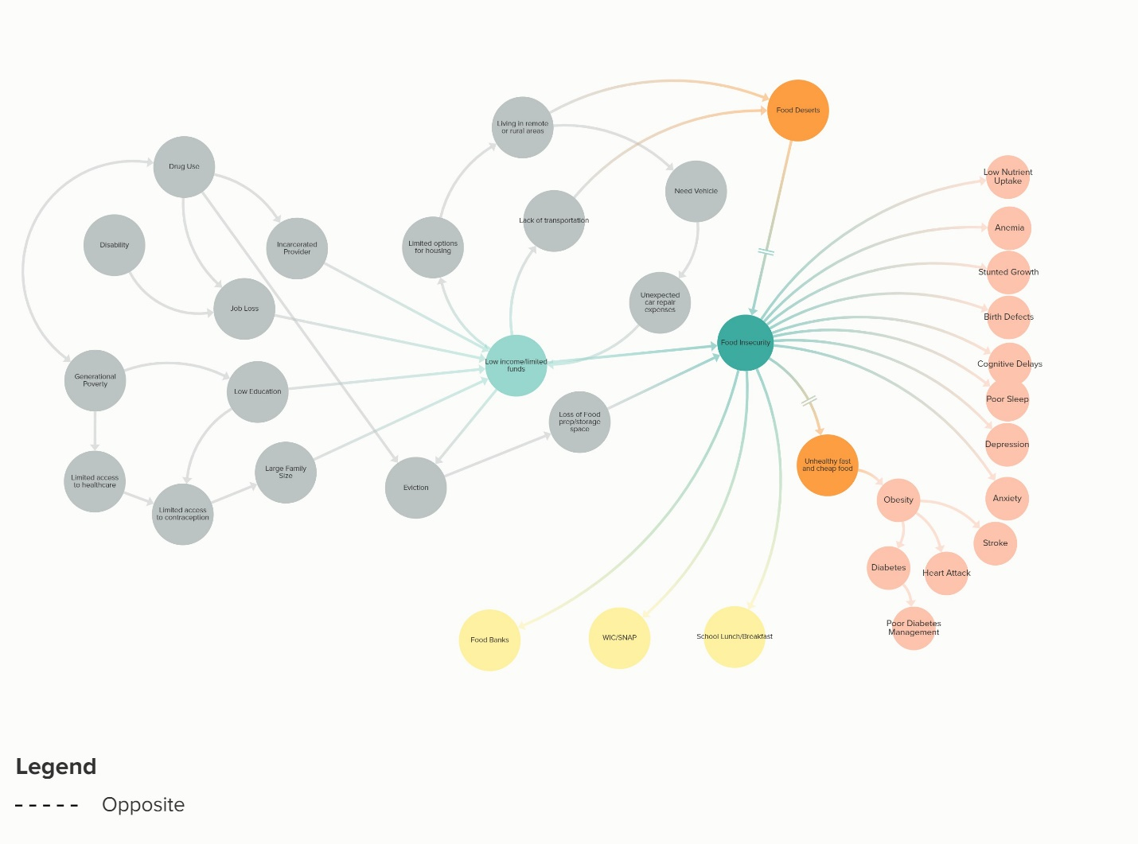
This systems thinking diagram outlines some of the pathways that operate to impact food insecurity in America. Food insecurity, which is defined by USDA as a lack on consistent access to the food required to support a healthy and active lifestyle, is an issue that impacted an estimated 37 million Americans in 2018 (1,2). There are numerous health issues in both children and adults identified as resulting from food insecurity, some being low nutrient uptake, stunted growth and mental health concerns (3). One of the most significant and obvious causes of food insecurity is a lack of funds to spend on groceries, however this diagram sought to disentangle the issues that contributed to families not having the funds to spend on groceries. Another area that this diagram demonstrates in the cycle of remote or rural living and food deserts. A food desert is defined as by a number of factors, such as, the distance to a store or the number of stores in an area, individual-level resources that may affect accessibility, such as family income or vehicle availability and neighborhood-level indicators of resources, such as the average income of the neighborhood and the availability of public transportation (4). This diagram also includes the factors that act to lessen the impact of food insecurity (shown in yellow) such as community level food banks and national programs that address food insecurity. Together, this diagram addresses some of the issues that contribute to food insecurity, the health outcomes of food insecurity and factors that exist to lessen the impact of food insecurity.
The two leverage points that were identified in this system were food deserts and cheap unhealthy alternatives to fresh food. These factors were chosen because from the context of this system they appeared to be relatively changeable interventions that would directly impact food insecurity, in the case of food deserts and would be able to lessen the poor health outcomes associated with this issue, in the case of the unhealthy alternatives. The factors demonstrated on the far left of the diagram were very entangled within each other and did not appear to be areas that where changes would be straight forward or areas that would be able to create strong noticeable changes on this specific issue.
Addressing food deserts means reducing or eliminating the areas that are impacted by food deserts. Examples include creating tax benefits that promote grocery stores moving to remote areas, mobile grocery stores and a federal benefits program for car repairs for low income families in vehicle dependent areas. All of these interventions would be reliant on funding structures and political climates to support them and program planning to launch them. By decreasing food deserts, both by directly decreasing a lack of grocery stores and through supporting families who need a vehicle to get to a grocery store, food insecurity would be decreased.
To limited unhealthy cheap options would decrease the negative health outcomes of food insecurity, such as obesity, diabetes, heart attack and stroke. Examples of how this leverage point could be acted on include creating a tax on sugary beverages and fast food (perhaps this revenue could be directed into the food desert intervention), supporting convenience stores in providing fresh produce options in store and creating zoning laws that prevent low income communities from being disproportionately impacted by the proximity of fast food restaurants and convenience stores. These interventions would require political support and a strong partnership with convenience stores to change their in store offerings. By changing the landscape of cheap and accessible foods from highly processed, high fat and high sugar options to more healthy alternatives, the negative health outcomes experienced by those experiencing food insecurity could be lessened.

References
Gundersen,C. & Ziliak, J. P. (2015). Food Insecurity And Health Outcomes. Health Affairs. 2015 34:11, 1830-1839. Retrieved from https://www.healthaffairs.org/doi/full/10.1377/hlthaff.2015.0645
Feeding America. (n.d.). Understanding Food Insecurity. Retrieved from https://hungerandhealth.feedingamerica.org/understand-food-insecurity/
USDA. (2019). Food Research Atlas. Retrieved from https://www.ers.usda.gov/data-products/food-access-research-atlas/documentation/
USDA. (n.d.). Definitions of Food Security. Retrieved from https://www.ers.usda.gov/topics/food-nutrition-assistance/food-security-in-the-us/definitions-of-food-security.aspx.

